Play for Peace
Swaziland
Skidmore College
Melvis Langyintuo, Ghana, Skidmore College &
Johane Simelane, Swaziland, Skidmore College, UWCSA-WK
Goals of the Project:
The mission of our Project was to use the language of sport to encourage the unity of a community through the construction of a sports field complex and illustrate that “playing sports for peace and unity” can strengthen a society. Also, we sought to demonstrate that even small daily contributions from each member of a community can bring prosperity; overall, we wish to develop the knowledge that when a community comes together diligently and willingly, great change can be achieved.
Pre-Project Initiatives:
Our Project began well before the start of the 2010 summer season. After being awarded the grant in February, we began earnest communication with our contacts in Swaziland and at Skidmore to prepare for our formal initiation of the project.
Saratoga Springs, NY: At Skidmore we focused our attention on informing and educating the Skidmore/Saratoga community about the Project. The actions we took involved presenting the Project to the Skidmore administration, faculty, students, and the Saratoga community. Our efforts to spread the awareness for our Project resulted in the donation of athletic apparel from Skidmore athletics, a contribution of extra funds from a Board of Trustee member, Donald Sussman, and lastly, the participation of 5th grade students from Saratoga who provided school supply bags for the children of the Mpolonjeni.
Mbabane, Swaziland: Upon arrival in Swaziland, our initial tasks involved:
1) MEETINGS: We held formal meetings to coordinate tasks and request assistance from various groups in Swaziland. Meetings were held with: UWCSA-WK faculty and students and the Mpolonjeni community members and chief. 2) TEAMS: From the WK school community, we assigned many students into different project teams (media, financial, field work, and management/planning) and from Mpolonjeni, we created a youth team.3) PROGRAM/OBJECTIVES: We reassessed our initial schedule of objectives and coordinated with our supporters and teams to create a revised task, one list that suited all participating parties. The new schedule included the contractors’ work dates, the order of objectives to complete and lastly, the tentative structure of our inaugural Sports Day program.
Construction of the Soccer Pitch and Volleyball/Basketball Court:
We embarked on our mission with members of both communities: Mpolonjeni and UWCSA. The various work teams we created at the start of the Project proved to be very influential due to the large scope of the Project. The site was on the top of a hill in the Hhohho region and although travelling to the location was a daily challenge due to the mountainous terrain and the unpaved, long, bumpy, winding and, unending roads, once we reached our location, our overall mission inspired our unlimited energy!
Our project commenced with marking the boundaries of the field followed by the big earth moving machines (excavator, grader, and bulldozer) that began moving the red soil and numerous boulders in order to level the ground. We began the Project by digging the foundation for the basketball/volleyball court. We used unfamiliar tools such as picks and spades, and as the days passed, we became professional trench diggers. Once the soccer field was leveled, we marked the field lines with white wash, transported the goal posts and a water tank from Mbabane to the site, and we built a toilet. In addition to the sports field, with the funds from Mr. Sussman, we renovated the Mpolonjeni Child Care Center, built a stone stove, and provided a water tank.
After completing the field, we planned the inaugural Sports Day. We created a schedule of events such as: soccer matches, food, music, kids’ field games, speeches, and a prize ceremony.
Achievements and Challenges:
Our goal of unifying communities within Swaziland under the language of sports flourished seamlessly since day one. Our media team was proactive at sending reports of the Project to Swazi media outlets. In addition, the members of UWC and Mpolonjeni who worked with us together enjoyed the experience and communicated with each other effortlessly in both English and Siswati. We created an environment that accepts and allows for the progression towards peace by constructing an activity that seamlessly supports the ability to share cultural, national, and personal backgrounds. This helped us to achieve our goals such as: the successful unity of the Mpolonjeni community, utilizing the Swazi media to communicate our mission and encourage action from the youth country wide to work together for societal prosperity, and the successful completion of the sports soccer pitch.
Although we were able to accomplish our main goals, this was not done without encountering some setbacks. The main challenges we encountered included: disagreements about the location of the field, and construction difficulties due to the mountainous terrain. In the beginning of the Project political disagreements about the exact location of the field consumed most of our time. These disputes seemed to be endless and they caused great frustration and disappointment for us until the Chief chose the Hhohho hills as the site because of its central location. The other major challenge involved reshaping the sports field ground due to the rocky and mountainous terrain. This long and treacherous task resulted in the consumption of most of our funds, thus, causing us to be unable to finish the volleyball/basketball court. However, UWCSA-WK has agreed to continue sponsoring our Project. They will complete the court during the 2010-2011 school year. Although we faced serious setbacks, we had structured great teams; so when we were down, they were there to pick us up. The fluid coordination and cooperation from everyone involved paved the way for the successful completion of the Project. The number of people who benefitted and will benefit from this project is immense. Overall, over 500 people participated in our inaugural Sports Day, 150 students from UWC helped out and through word of mouth and our effective use of the media, many more communities will be influenced. Moreover, our pre-project and post project initiatives have made children and families in both Saratoga Springs and Mpolonjeni affected by our mission and new friendships have been fostered.
Long-term impact and Future of “Play for Peace”:
After our momentous Sports Day, the Mpolonjeni Sports Field was officially handed over to the community! Today, it is the responsibility of each member not to claim personal ownership of the field but to work together to uphold the mission that we hoped to accomplish. We want the youth to use sports and their experiences from creating the Sports Field as a means to unite and become responsible for their actions within the community. This will be reflected in the community benefiting as best as it can from the little it receives. Overall, the Project has enhanced and encouraged a sense of responsibility, improvement, sustainability, and management from each individual, young and old. As a result of the highly effective use of the Swazi media (TV, radio, & newspapers) throughout our Project, we also expect and hope that other communities will be challenged to improve their lives through unity and making use of any help they can get for the best of their societies. Ultimately, the unity of the youth we witnessed while working on this Project gives the hope that Swaziland will be able to reduce the depressing rates of HIV/AIDS and poverty in the future. It may not be fast as one might hope, but it all truly starts with something as simple as, “playing for peace and unity,” thus creating the way for a brighter future.
Peace through our Eyes:
We define peace as the coming together of people of similar and distinct cultures, traditions, and experiences to unite and use their individual and collective talents to the best of their abilities for societal prosperity. This involves accepting, assessing, and learning about the past, present, and future in an effort to contribute to the attainment of peace. Our project contributes to peace in the short term because it unites a community under common goals for societal prosperity. In the long term, our use of the media and immense empowerment of the youth throughout all stages of the project will create a sense of responsibility, improvement, sustainability, and management about the societies that they live in and the actions they should keep up to maintain a peaceful environment. This project has made us to see the world as a place where tiny daily contributions of any kind from each member of the society can greatly benefit a society. The project has made us to be even more grateful of all the resources provided to us today and to utilize what ever help we can offer to the deserving. This project has also made us to realize that nothing is worth doing unless you do it to the best of your abilities. Ultimately we feel that it may be hard to unite people, but as soon as people realize their differences and accept them, it becomes easy to maintain peace and help people learn that a simple idea can flourish to influence great societal change.
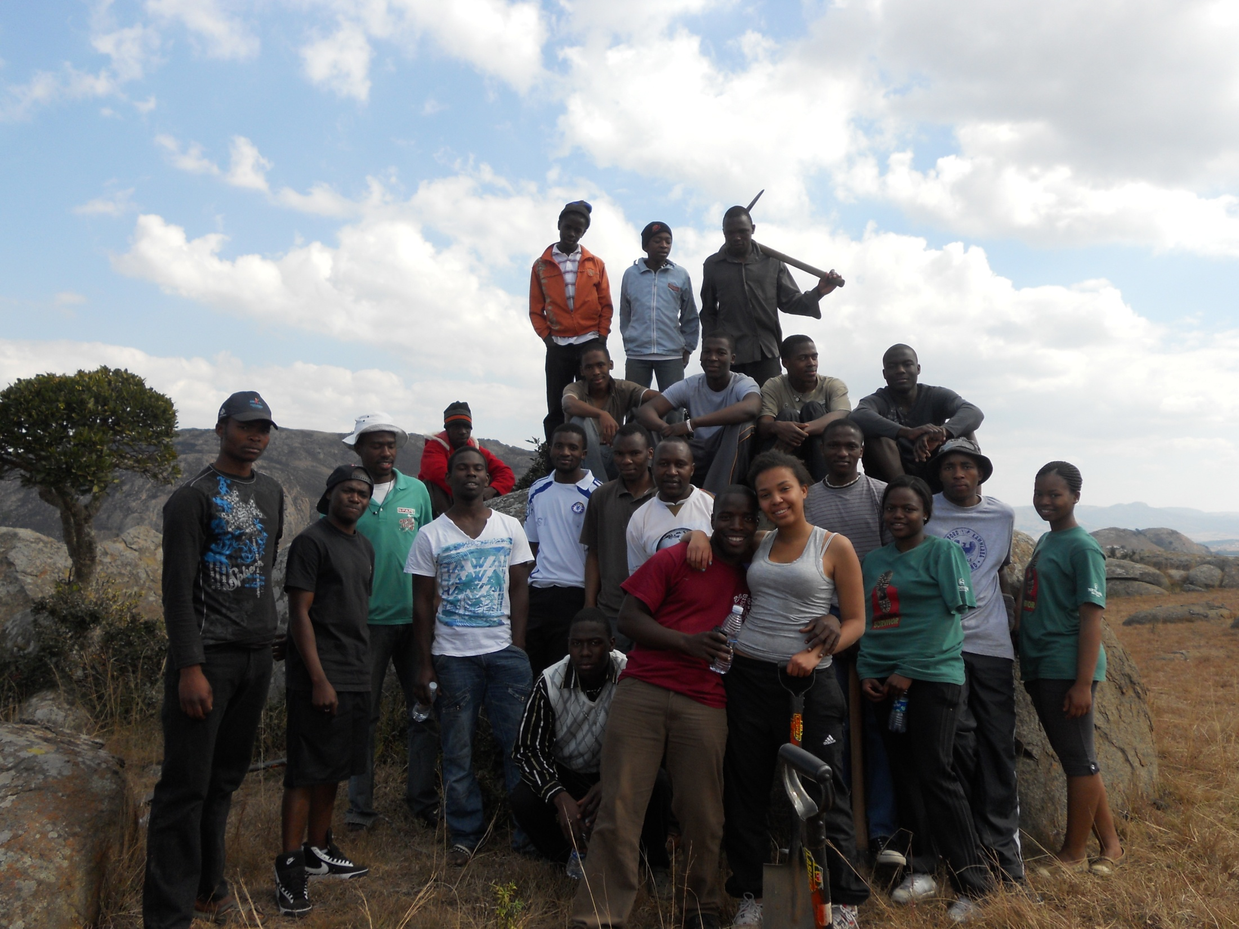
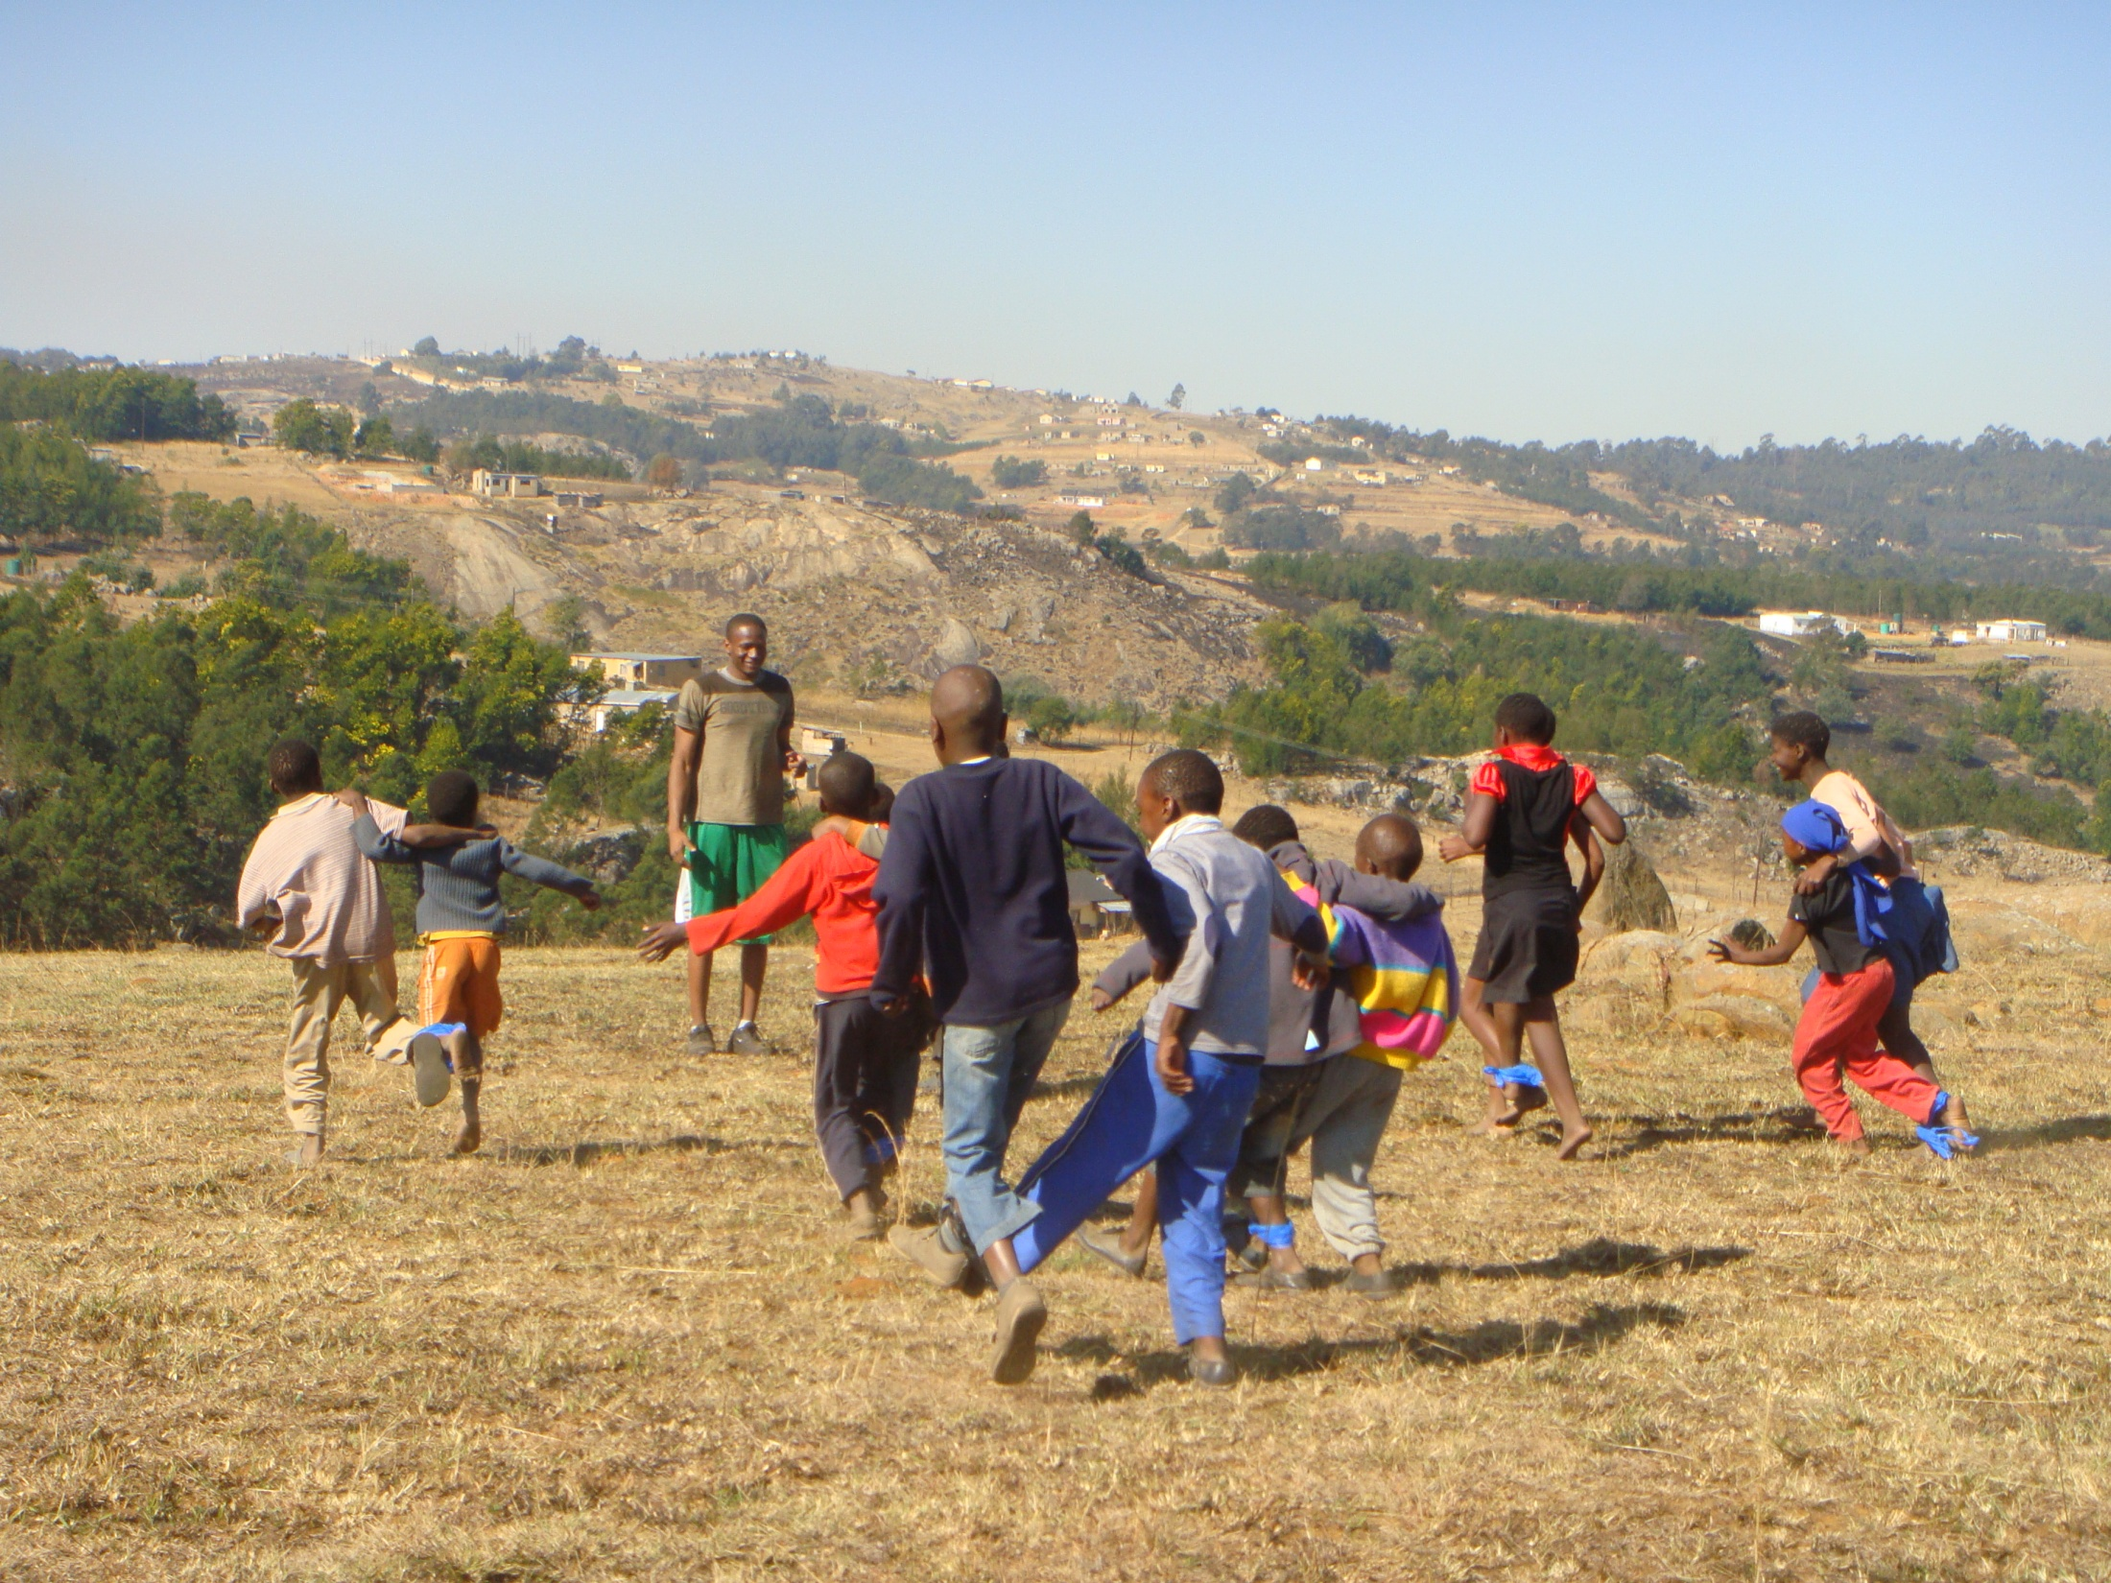
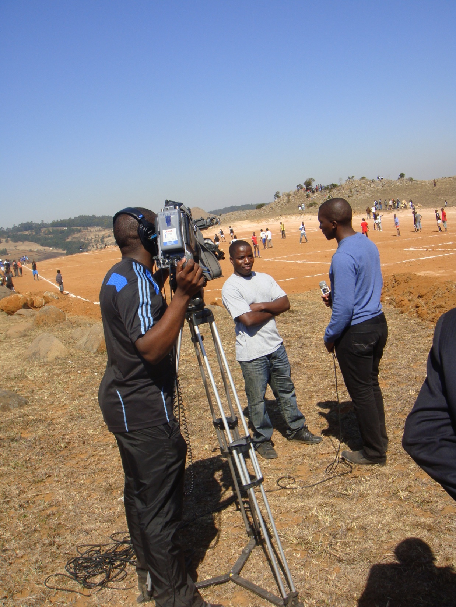
 |  |  |  |  |  |  |  |  |  | Rands |  |  | US dollars
 |  |  |  |  |  |  |  | Debit |  | Credit |  | Debit | Credit
Total grant |  |  |  |  |  |  |  | 70000 |  |  |  | 10000
Construction Expenses
10 hrs excavator and grader |  |  |  |  |  |  |  |  |  | 10810 |  |  | 1544.286
10 hrs grader |  |  |  |  |  |  |  |  |  | 6200 |  |  | 885.7143
3 hrs excavator + 7 hrs grader |  |  |  |  |  |  |  |  |  | 6125 |  |  | 875
Tank + fittings |  |  |  |  |  |  |  |  |  | 2764 |  |  | 394.8571
Field toilet + fittings |  |  |  |  |  |  |  |  |  | 1026 |  |  | 146.5714
Round tube steel (for goal posts) |  |  |  |  |  |  |  |  |  | 1476 |  |  | 210.8571
10 bags of glutex (marking field) |  |  |  |  |  |  |  |  |  | 1000 |  |  | 142.8571
10 hrs grader |  |  |  |  |  |  |  |  |  | 6200 |  |  | 885.7143
5000 litres of tankered water |  |  |  |  |  |  |  |  |  | 95.2 |  |  | 13.6
brick stove material |  |  |  |  |  |  |  |  |  | 3707 |  |  | 529.5714
total construction expenses |  |  |  |  |  |  |  |  |  | 39403.2 |  |  | 5629.029
Transport expenses
transporting steel bars to soup kitchen |  |  |  |  |  |  |  |  | 170 |  |  |  | 24.2857
transporting sand, crush, cement ,etc to field |  |  |  |  |  |  |  |  | 500 |  |  |  | 71.4285
transporting goal posts |  |  |  |  |  |  |  |  |  | 700 |  |  |  | 100
car rental for 3 months |  |  |  |  |  |  |  |  |  | 6000 |  |  |  | 857.1429
total fuel |  |  |  |  |  |  |  |  |  | 7000 |  |  |  | 1000
total transport expenses |  |  |  |  |  |  |  |  |  | 14370 |  |  |  | 2052.857
Communication and Food Expenses
total airtime (minutes) |  |  |  |  |  |  |  |  |  | 450 |  |  |  | 64.28571
meeting expenses |  |  |  |  |  |  |  |  |  | 300 |  |  |  | 42.85714
total food expenses |  |  |  |  |  |  |  |  |  | 2693 |  |  |  | 384.7143
skype |  |  |  |  |  |  |  |  |  | 700 |  |  |  | 100
total communication and food expenses |  |  |  |  |  |  |  |  | 4143 |  |  |  | 591.857
contractors payments
welding at the soup kitchen |  |  |  |  |  |  |  |  |  | 1800 |  |  |  | 257.1429
welding goal posts |  |  |  |  |  |  |  |  |  | 1000 |  |  |  | 142.8571
building stove |  |  |  |  |  |  |  |  |  | 800 |  |  |  | 114.2857
sport field marking |  |  |  |  |  |  |  |  |  | 200 |  |  |  | 28.57143
Total contractors payments |  |  |  |  |  |  |  |  |  | 3800 |  |  |  | 542.8571
Opening event expenses
prizes for games at event |  |  |  |  |  |  |  |  |  | 1000 |  |  |  | 142.8571
renting a tent |  |  |  |  |  |  |  |  |  | 550 |  |  |  | 78.57143
food expenses |  |  |  |  |  |  |  |  |  | 5000 |  |  |  | 714.2857
Total opening event expenses |  |  |  |  |  |  |  |  |  | 14370 |  |  |  | 2052.857
Other Expenses
luggage + documentary materials |  |  |  |  |  |  |  |  |  | 9387 |  |  |  | 1341
Melvis' Flight and living expenses |  |  |  |  |  |  |  |  |  | 8000 |  |  |  | 1142.857
American adapter |  |  |  |  |  |  |  |  |  | 80 |  |  |  | 11.42857
total other expenses |  |  |  |  |  |  |  |  |  | 17467 |  |  |  | 2495.286
Overall balances |  |  |  |  |  |  |  | 70000 |  | 93553.2 |  | 10000 |  | 13364.74

